****Camcorder and Zoom****

* **Use Laptop #1 (Zoom / Camcorder) and old Atem Mini  
  Connect micro HDMI to camcorder and larger HDMI to Atem Mini as usual**
* **Zoom settings  
  Audio… Microphone: Black Magic Design Speaker: Headphones  
  Video… Black Magic Design**
* **Activate mic 1 and camcorder sound on Atem: On / Off**
* **If using the Parish Hall Fender Amp, connected portable speakers, bluetooth mic...  
  Connect 15’ male to male 3.5mm audio cable to Fender amp’s phones output and Atem mic 1**
* **If not using Fender Amp use wifi mic located near the pulpit.  
  Use wifi mic receiver (to the left of soundboard on tech table).   
  Attach 1/8” to ¼” adapter to 15’ audio cable. Plug into wifi receiver and other end into Atem**
* **Connect black USB C (webcam out) to Atem. Plug other end of USB A (laptop) into hub**

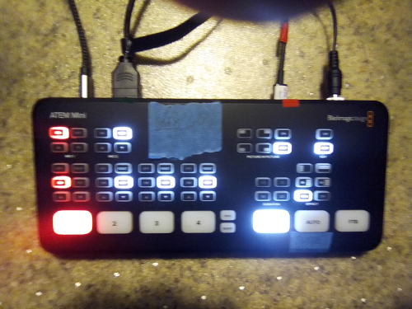

**Cables from left to right**

* **mic 1: 15’ braided 3.5mm male to male audio (if using Fender amp)  
  or, mic 1: wifi mic dongle (not pictured) (if using wifi mic)**
* **HDMI cable from camcorder (as usual)**
* **black USB C into Atem webcam output… USB A into laptop.**
* **Power cable**